**SQL-Based Data Analysis in the Manufacturing Industry**

**Created by: Rekha Devendra**

**Introduction:**

In my project, I embarked on a journey of SQL-Based Data Analysis in the Manufacturing Industry. This project provides a deep dive into a fascinating case study, showcasing my process and the valuable insights from the analysis. Join me as we explore the data-driven manufacturing world, where SQL becomes a powerful tool for uncovering hidden trends, optimizing processes, and enhancing decision-making.

**Dataset:**

The database **"Manufacturing_Industry"** consists of four tables, each serving a specific purpose. Below are the different tables and a brief description of them:

1. **Table Name:** products

**Description:** This table contains information about the various products manufactured by the company. It includes product names, prices, descriptions, and the materials used to produce them.

1. **Table Name:** orders

**Description:** The orders table tracks customer orders, including order IDs, customer names, order dates, statuses, and the associated product IDs. It enables us to monitor the sales and fulfillment processes.

1. **Table Name:** suppliers

**Description:** This table is responsible for managing supplier-related information. It stores supplier IDs, names, contact details (phone numbers and addresses), and the product IDs they supply. This data helps in supplier management and product sourcing.

1. **Table Name:** materials

**Description:** The materials table records information about the raw materials used in manufacturing. It includes data such as material names, prices, and descriptions. Understanding these materials is crucial for cost analysis and quality control.

These tables provide a comprehensive perspective of the manufacturing industry's database, making data analysis, decision-making, and process optimization easier.

* **Note:** The database analysis was conducted using PostgreSQL.

**Below are the SQL codes used to create the tables:**



**Below are the SQL codes used to insert values into the tables:**



**Below are the SQL codes used for data analysis and their functions:**



**Manufacturing_Industry Relational schema:**

Before diving into the analyses, my initial step was to comprehend the Entity Relationship Model (ERM) of this database, often referred to as the schema. Here's an overview of the schema:

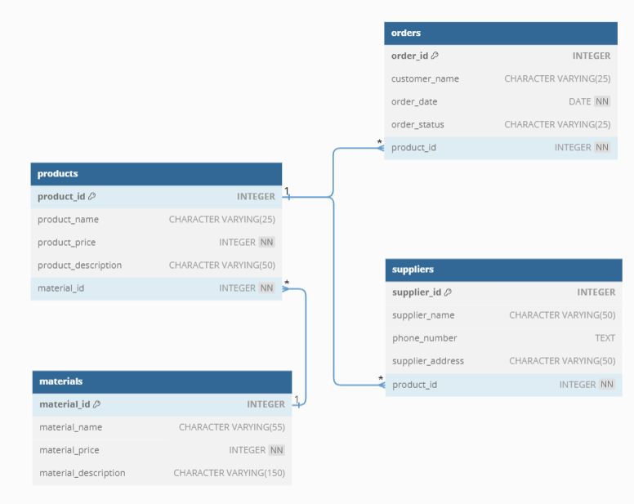

**Goals of Analysis:**

**1) Retrieve detailed information about orders and their associated products and materials.**

**Objective:** Combining data from multiple tables to understand the relationships between orders, products, materials, and suppliers.

In this query, the tables used to join are: **'orders,' 'products,' 'materials,' and 'suppliers.'**

Below is the query I used to extract the necessary information:

* **Insights:**
* The output demonstrates the diversity of materials and products in the manufacturing industry. Products range from "Steel Beam" to "Ceramic Mug Set," showcasing materials like steel, aluminum, copper, plastic, and more. This diversity underscores the complexity of modern manufacturing operations.

**2) Find out which products and materials have the highest demand and how many orders they are associated with.**

**Objective:** Aggregate data to get insights into popular products and materials.

In this query, the tables used to join are: **'products' and 'materials.’**

Below is the query I used to extract the necessary information:

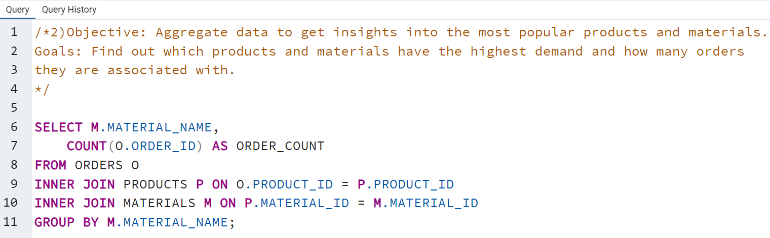

* **Insights:**
* **Diverse Material Utilization:** The results show that a wide range of materials, ranging from "PVC Pipe" to "Plastic Resin," appear in only one order. This suggests that the manufacturing process uses various materials, with each order requiring a unique combination.
* **Low Order Count Per Material:** Across the listed materials, there is a consistent count of 1 order per material. This indicates that, in the dataset, there are no standout materials with significantly higher demand.

**3) Categorize product orders into three price categories ('Low,' 'Medium,' and 'High') based on their prices and limit the results.**

**Objectives:** Categorize the product orders by price into three distinct categories to gain insights into pricing distribution.

* Display a limited set of the categorized product orders for quick assessment and review.

In this query, the tables used to join are: **'orders' and 'products.'**

Below is the query I used to extract the necessary information:

* **Insights:**
* **The "High" Price Category Dominates** - Among the categorized product orders, the "High" price category is predominant, suggesting that a significant portion of orders falls into the high-price range. This insight highlights a potential area for increased profitability within the manufacturing industry.
* **High-Value Orders Concentrated on a Single Day -** The output table shows that all "High" price category orders were placed on the same date, "2023-10-14." This indicates a notable concentration of high-value orders on that day, potentially due to a specific sales event or promotional campaign.

**4) Analyze the manufacturing data to identify the top customers with the highest order values.**

**Objectives:** 1) Group orders by customer name.

2) Calculate the total order value for each customer.

3) Identify the top customers based on their total order values.

4) Limit the result set to a specific number of top customers.

In this query, the tables used to join are: **‘products’ and ‘orders.'**

Below is the query I used to extract the necessary information:

* **Insights:**
* **Top Customers by Order Value:** The analysis reveals that "Creative Works" is the top customer with the highest total order value of 700.
* **Diverse Range of Customers:** The output demonstrates a diversity of customers among the top 10, ranging from "Elite Machinists" and "Techtronics Inc." to "MegaMakers" and "Industrial Creations."

**5) Objectives: Analyze product pricing within specific price ranges and identify products with unique price points.**

1) Calculate and display the minimum and maximum product prices.

2) Identify products with unique price points within specific price ranges.

In this query, the tables used are: **'products.’**

Below is the query I used to extract the necessary information:

1) Calculate and display the minimum and maximum product prices.

* **Insights:**
* The analysis of product pricing reveals that the minimum product price in the dataset is $15, while the maximum product price is $700.

2) Identify products with unique price points within specific price ranges.

* **Insights:**
* Within the specific price range of $100 to $200, several products have unique price points. Notably, products like "Aluminum Frame," "Copper Wire Spool," and "Wooden Table" are priced at distinct values within this range.

**6) Objective: The main objective is to provide additional insights into the pricing structure of products in the dataset.**

1) Calculate the total price of all products in the dataset.

2) Calculate the average price of products.

3) Determine the price difference between the product with the highest price and the lowest price.

In this query, the tables used are: **'products.'**

Below is the query I used to extract the necessary information:

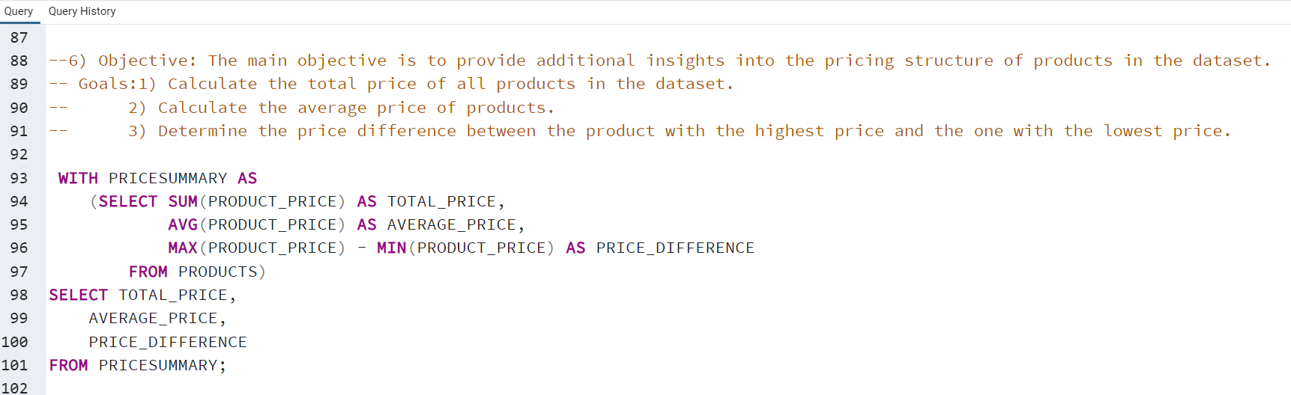

* **Insights:**
* **Total Product Price:** The total price of all products in the dataset is $4,950.
* **Price Variation:** The price difference between the product with the highest price and the one with the lowest price is $685.

**7) Create a view to consolidate product order details from the provided manufacturing tables, with the goal of providing a unified and easily accessible view of product orders.**

**Objectives:** 1) Consolidate product order details from multiple tables into a single view.

2) Provide a clear and unified view of product order data for analysis and reporting.

3) Simplify access to product order information for various stakeholders in the manufacturing process.

In this query, the tables used to join are: **'orders,' 'products,’ and 'materials.'**

Below is the query I used to extract the necessary information:

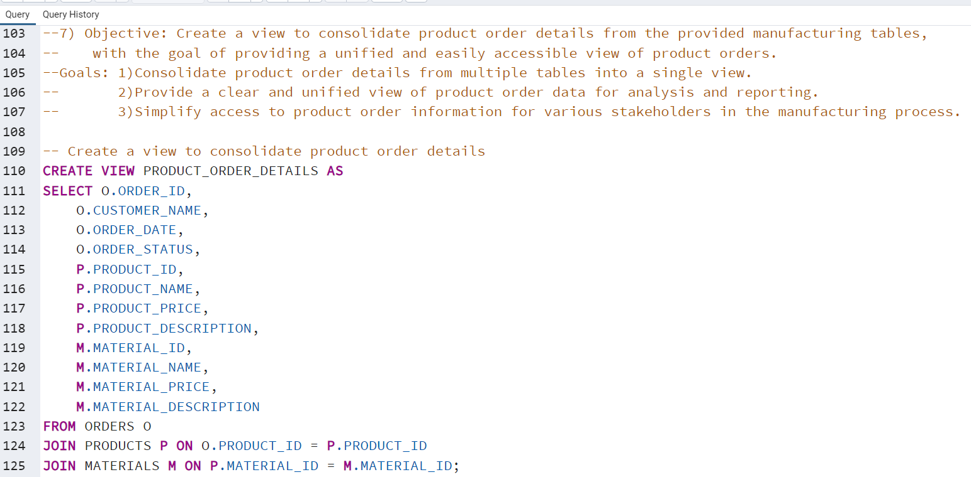

* **Insights:**
* The creation of the **"PRODUCT_ORDER_DETAILS" view** consolidates product order details from multiple manufacturing tables into a single, unified view. This simplification allows various stakeholders in the manufacturing process to access and analyze product order information more efficiently.

**8) Creating a funnel-like structure view for the manufacturing tables can be a useful way to visualize and analyze data.**

**Objectives:** The idea is to segment the data in a step-by-step manner, just like a funnel narrows down as we progress through different stages.

In the context of manufacturing, this could be used to track the progress of products or orders through various stages of production, such as material selection, production, quality control, and shipping.

In this query, the tables used are: **'orders' and** subqueries within the **Common Table Expression (CTE)**.

Below is the query I used to extract the necessary information:

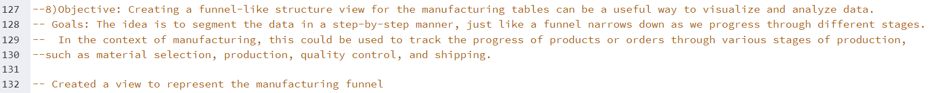

* **Insights:**
* **Uniform Progression:** The manufacturing funnel view illustrates that there is a uniform distribution of orders across various stages. Specifically, there are 30 orders each at the "Order Received," "Material Selected," and "Product Manufactured" stages.
* **Quality Control Efficiency:** Out of the initial 30 orders, only 10 have reached the "Shipped" stage. This implies that a significant portion of orders is still in the production process or awaiting quality control.

**9) Create a view that combines order and supplier details from the provided tables, enhancing the ability to access and analyze data for manufacturing operations.**

**Objectives:** 1) Consolidate order and supplier details into a single view, simplifying data access.

2) Facilitate data analysis and decision-making by providing an integrated view of orders and their corresponding suppliers.

In this query, the tables used to join are: **'orders,' 'products,' and 'suppliers.'**

Below is the query I used to extract the necessary information:

* **Insights:**
* **Simplified Information Integration:** The "ORDER_SUPPLIER_DETAILS" view combines order and supplier data, making it a handy one-stop source. This helps easily keep track of orders and quickly spot which suppliers are part of the manufacturing process, much like having neatly organized data in one place.
* **Smart Decision Support:** This view empowers decision-makers by offering a complete view of orders and suppliers. It's like having a complete picture of manufacturing operations, with customer details and product information on one side and supplier names, contact details, and addresses on the other. This makes it easy to choose suitable suppliers, track orders, and optimize processes.

**10) Objectives: To categorize the product orders based on specific keywords or patterns within their product names and descriptions, with the goal of identifying and analyzing orders that match predefined criteria.**

* Facilitate analysis and decision-making by providing a structured view of orders that match the specified criteria.

In this query, the tables used to join are: **'products’ and 'orders.'**

Below is the query I used to extract the necessary information:

* **Insights:**
* By categorizing product orders into "Steel Products," "Plastic Products," "Copper Products," and "Other Products" based on keywords in their names and descriptions, we can quickly identify and analyze specific product groups. This categorization simplifies inventory management, sales strategy, and product analysis for manufacturers.

**11) Extracting and formatting data in a useful way, such as formatting phone numbers for readability**

**Objective:** Extract phone numbers with a specific format.

In this query, the tables used are: **'suppliers.'**

Below is the query I used to extract the necessary information:

* **Insights:**
* **Uniform Phone Number Format:** The analysis successfully extracted and formatted phone numbers for suppliers in a consistent and reader-friendly manner, with all phone numbers now appearing in the format "(XXX) XXX-XXXX."

In conclusion, this project delved into SQL-based data analysis within the Manufacturing Industry, uncovering valuable insights and trends. Establishing interconnected tables - Products, Orders, Suppliers, and Materials - provided the foundation for a comprehensive analysis of manufacturing processes. Through the power of SQL, we explored the intricacies of product relationships, order management, and supplier information. This project serves as an example of how SQL has the potential to be an effective tool for streamlining manufacturing operations and promoting data-driven decision-making.